Larry Pesavento, a trading veteran of over 40 years, and Leslie Jouflas explain the AB=CD pattern and how we can use it

**History of the AB=CD Pattern**

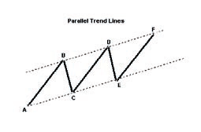In 1935 a book was published for sale to investors at an incredible price of $1500. That book was Profits in the Stock Market by H.M. Gartley. On page 249 Gartley describes a chart pattern, “Practical Use of Trend Lines”, which we now call the AB=CD Pattern.

Gartley’s description of the AB=CD pattern illustrated how the market would rally in an uptrend and then retrace. It would then rally to another uptrend then make another retracement forming an upsloping parallel channel. It was from this description that the AB=CD pattern achieved its nickname as the “Lightning Bolt”.

Gartley spent several pages referring to these trend lines and parallel lines as excellent signals when used in conjunction with other working tools. He also applied these lines to price ratios.He used mainly ratios of one third and half retracements.

**AB=CD Pattern Structure**

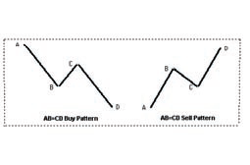The AB=CD pattern is found in all markets and on all time frames. The pattern is a measured move where the second leg is “equal” to the first leg. It should be noted that the C-D leg can extend and will not always be exactly “equal”.

There are three legs that form this pattern. The first leg of the pattern is labeled A-B. After the completion of the first leg, a retracement or correction will occur that will usually find support or resistance at one of these Fibonacci levels; .382, .50, .618 or .786. This correction or retracement is labeled BC and is the second leg of the pattern. (Note: Strongly trending markets will usually see only a retracement to the .382.

Once price resumes in the same direction of the A-B leg the C-D leg then begins to form. Once we identify the CD leg forming we can project the potential pattern completion and form a trading strategy. As the CD leg forms and completes we will monitor the final leg for any warning signs that would alert us to a change in market conditions that may signal us to possibly pass on the trade or wait for further confirmation before entering the trade. Warning signs would include:

* Wide range bars
* Gaps near completion in the CD leg
* Tail closes in opposite direction of trade

When studying this pattern it is important to know what invalidates the pattern. Here are three items that would invalidate the AB=CD pattern:

1. C can not exceed A. Meaning the retracement of AB can not exceed 1.00
2. C can be a 1.00 retracement of the AB leg, this is a rare pattern and a double top or bottom, but it is a valid pattern.
3. D must exceed B in order for the pattern to complete at D and be a valid AB=CD.

**Important Characteristics of the AB=CD Pattern**

The AB=CD pattern will be perfectly symmetrical, meaning AB equals CD about 40% of the time. The other 60% of the time variations of the pattern will be present. What this means is that after the AB leg is formed and the retracement leg, BC, has completed, the CD leg will be entirely different than the AB leg. The two legs may or may not be perfectly symmetrical.

Some of the ways the CD leg can vary from the AB leg are:

* CD leg is an extension of AB of anywhere from 1.27 to 2.00 or greater.
* CD leg has a slope or angle steeper or wider than AB. (See Figure 4)

At first glance this would make the trader think the pattern is not tradable. The key lies in identifying the BC leg. The most important thing is to watch the price action coming after point C has formed. The C leg determines the relationship to the AB leg.

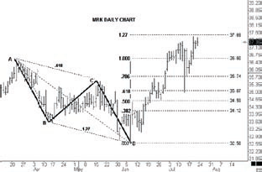

Figure 3

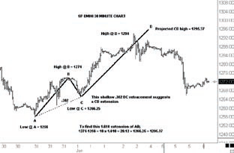

Figure 4

**Variations**

These C leg phenomena can be described in 3 ways:

* First; if after point C has occurred and a gap exists in the direction of point D, this will usually indicate that the CD leg will be much greater than the AB leg. It indicates a 1.27 or 1.618 of AB).
* Second; a wide range bar (twice normal size) at point C is also another indication that the CD leg is going to be extended.
* Third; ideally AB=CD moves are symmetrical in price and time. For example; if the AB leg is 6 bars up then the CD leg will be 6 bars up. (See Figure 5)

This next sentence is very important, if the CD leg is made in just a few bars that will strongly indicate that the CD leg is going to be an expansion of the AB leg. You can imagine as an example of this thrust principle – if you had 2 Ferrari automobiles on the racetrack, one with diesel fuel the other with high tech gasoline, it would be easy to understand the high tech gasoline powered Ferrari getting to the finish line first. Watch the C leg, because if it starts fast, that is the faster Ferrari going further, faster.

**Slope and Time Frames**

The slope or time frame of the BC move can also be helpful in determining the pattern. BC legs usually will correct to one of the ratios; .382, .50, .618 or .786. The slope of this BC leg is usually a good indication of what the next CD leg will be. For example; assume that the AB leg was 15 trading bars to point B and now the BC leg has taken 8 bars and has only retraced .382% of the AB leg. This is a sign of the market absorbing a lot of selling at a high price, it is a shallow retracement and was not able to retrace to .50, .618 or .786%. (See Figure 4) We would assume that prices would go much higher and possibly quite rapidly once the selling slows. However, if the market retraces to a .618 or .786 retracement, the CD will most probably be a normal move equaling AB=CD. (See Figure 3)

To figure the extension of the CD leg use the difference of the AB leg and multiply by 1.27 or 1.618 then add that figure to the high of low of C. The example in Figure 4 would be figured like this:

(A = 1256 – B = 1274 = 18 points)

18 x 1.618 in this chart example = 22.86

add this to C: 1266.25 + 22.86 = 1285.37

which is the projection price at D for the 1.618 extension.

If figuring the 1.27 or other extension numbers simply use that number in place of the 1.618).

Time Bars in the AB=CD pattern will usually be a range from 5 to 8 bars. When the CD leg is extending beyond 8 bars in an up or down move the probability is for a price extension where CD will be 1.27 or 1.618 of the AB swing. (See Figure 5)

The reader should keep in mind that these patterns are only probabilities, they are not certainties and trying to use these patterns without a solid understanding of them, and a sound money management strategy is equivalent to trading suicide.

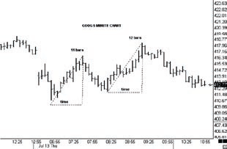

Figure 5

*Larry Pesavento is a veteran of over 40 years in trading. He is a former member of the Chicago Mercantile Exchange where he traded S&P futures and Foreign Currency. He also traded at the prestigious Commodity Corporation of Princeton New Jersey. He also managed Drexil Burham Lambert Commodity Department in Beverly Hills, California. Larry’s library of books and trading systems has been accumulated over the past 5 decades. Larry has written 9 books on trading ranging in subjects from Astro Harmonic phenomena, Pattern Recognition swing trading and Artificial Intelligence. He currently trades for a Hedge Fund and mentors private students on a one on one basis only. Larry can be reached at larry@tradingtutor.com or via his website www.tradingtutor.com*

*Leslie Jouflas has been a full time trader since 2000 and has begun trading private managed money. She also enjoys teaching and encouraging new students to the field of trading. Leslie met Larry several years ago while he was teaching a 5 day workshop. Leslie can be contacted at frredrica@msn.com*

*Larry Pesavento is the author of several books on trading and has co-authored a recent book with Leslie Jouflas titled, Essentials of Trading: It’s Not WHAT You Think – It’s HOW You Think*